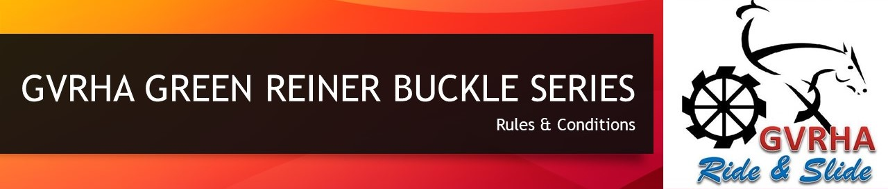

1. The GVRHA Green Reiner Buckle Series is open to any eligible GVRHA Green Reiner or GVRHA Beginner Rider.
2. The GVRHA Green Reiner Buckle Series replaces any Hi Point system previously used.
3. Competitor MUST be a financial member of GVRHA.
4. Qualifying classes for the series will be held at the following shows during 2024: February, March, April, May, June, August, September. A Top 10 Clean Slate Final will be held at the November show.
5. A competitor’s score from each GVRHA Green Reiner class held at each qualifying show will be added together and the Top 10 aggregate scores, plus ties, will advance to the clean slate final in November.
6. As per NRHA rules a zero is classed as a score and will be counted however a no score will not
7. To be eligible to advance to the clean slate final, competitors MUST compete at a minimum of three of the seven qualifying shows throughout the year. Only the top four Judges scores for each competitor will be added together and used to make up the aggregate.
8. The winner of the final will be presented with a Champion Trophy buckle.
9. All other GVRHA Entry Level class rules will apply (please refer to the GVRHA Entry Level Class Rules for GVRHA Green Reiner/ Beginner Rider eligibility)

<https://gvrha.com.au/wp-content/uploads/2022/07/GVRHA-Entry-Level-Conditions.docx.pdf>

Revision – January 2024